**PRAKTIKUM ALGORITMA STRUKTUR DATA**

**TEKNIK INFORMATIKA**

**(Contoh)**



Oleh :

Faathir Akbar Nugroho

4522210033

Kelas A

**Pseudocode (Contoh 1)**

**Kamus/Deklarasi Variabel**

Fatiri = int

*FatirnamaKu, FatirNM[8] = char

**Algoritma / Deskripsi**

*FatirNM[8] = {‘F’, ‘A’, ‘A’,’T’,’H’,’I’,’R’}

for (Fatiri=0; Fatiri < 8; Fatiri++)

FatirnamaKu = &FatirNM[Fatiri]

print(*FatirnamaKu)

endfor

**Algoritma/Bahasa Natural (Contoh 1)**

1. Fatiri <-- 0
2. *FatirNM[8] = {‘F’,‘A’,‘A’,’T’,’H’,’I’,’R’}
3. Selama (Fatiri < 8), kerjakan baris 4 s.d. 6
4. FatirnamaKu = &FatirNM[Fatiri]
5. Mencetak *FatirnamaKu
6. Fatiri <-- Fatiri + 1
7. Selesai

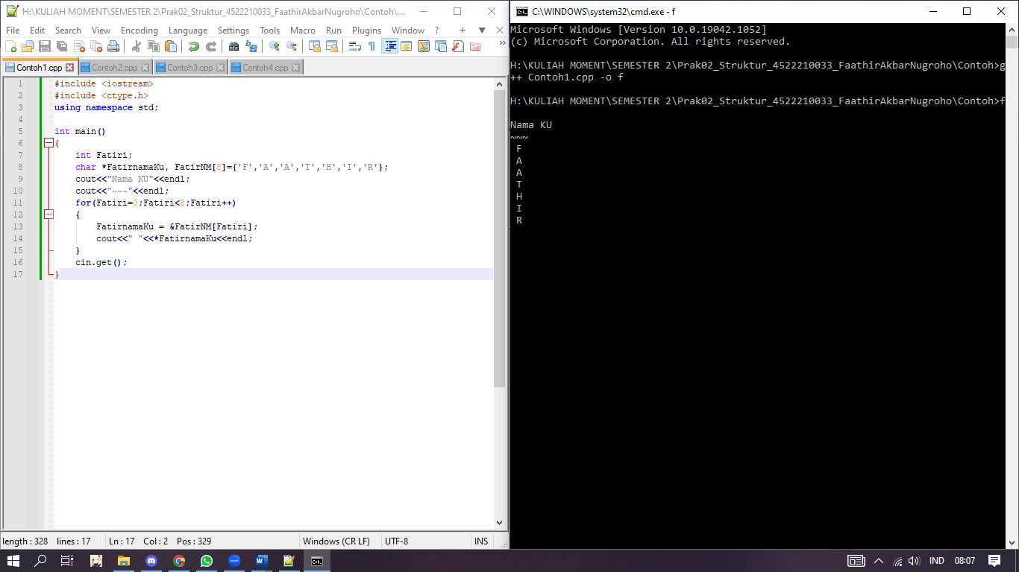**Program (Contoh 1)**

**Algoritma/Bahasa Natural (Contoh 2)**

1. Fatirn 🡨 44
2. Fatirpn 🡨 &Fatirn
3. Fatirppn 🡨 &Fatirpn
4. Menampilkan isi nilai/variable Fatirn
5. Menampilkan isi nilai/variable *Fatirpn
6. Menampilkan isi nilai/variable *Fatirppn
7. Menampilkan isi nilai/variable &Fatirn
8. Menampilkan isi nilai/variable &Fatirpn
9. Menampilkan isi nilai/variable &Fatirppn
10. Menampilkan isi nilai/variable Fatirn
11. Menampilkan isi nilai/variable Fatirpn
12. Menampilkan isi nilai/variable Fatirppn
13. Selesai

**Pseudocode (Contoh 2)**

**Kamus/Deklarasi Variabel**

Fatirn, *Fatirpn, **Fatirppn = int

**Algoritma/Deskripsi**

Fatir = 44

Fatirpn = &Fatirn

Fatirppn = &Fatirpn

print(Fatirn)

print(*Fatirpn)

print(**Fatirppn)

print(&Fatirn)

print(&Fatirpn)

print(&Fatirppn)

print(Fatirn)

print(Fatirpn)

print(Fatirppn)

**Program (Contoh 2)**

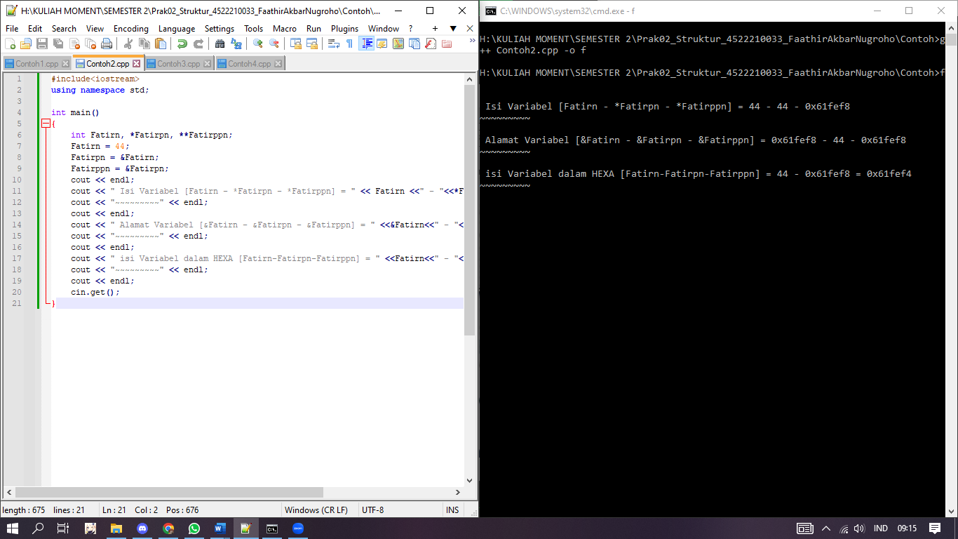

**Pseudocode (Contoh 3)**

**Kamus/Deklarasi Variabel**

*Fatirpn, Fatirpn = int

**Algoritma/Deskripsi**

Fatirpn = new int

*Fatirpn = 44

print(*Fatirpn)

**Algoritma/Bahasa Natural (Contoh 3)**

1. Membuat objek beritpe interger pada *Fatirpn
2. *Fatirpn = 44
3. Mencetak variable *Fatirpn
4. Selesai

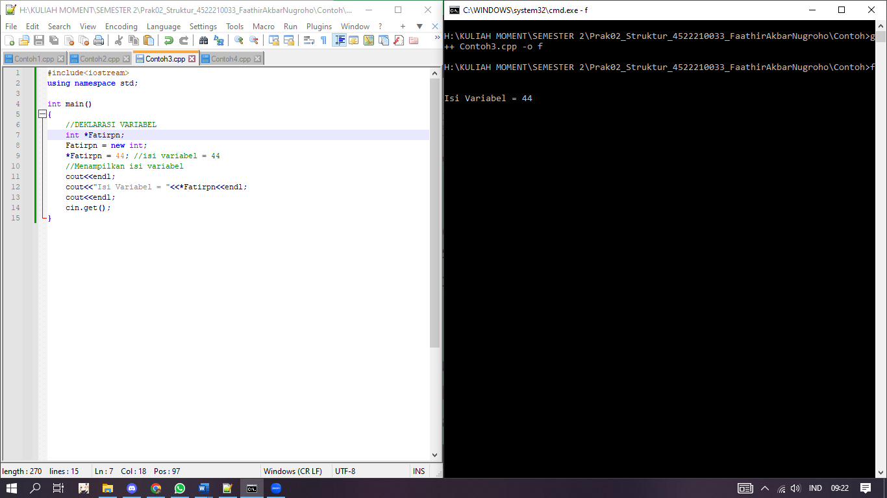**Program (Contoh 3)**

**Pseudocode (Contoh 4)**

**Kamus/Deklarasi Variabel**

FatirNilaiUTS, FatirNilaiUAS, FatirN1, FatirN2 = int

**Algoritma/Deskripsi**

struct Node (FatirNilaiUTS, FatirNilaiUAS, FatirN1, FatirN2)

Node *FatirP , *FatirQ

FatirP = new Node

FatirP -> FatirN1 = 99

FatirQ = new Node

FatirQ -> FatirN2 = 78

print(FatirP -> FatirN1)

print(FatirQ -> FatirN2)

**Algoritma/Bahasa Natural (Contoh 4)**

1. Mendeklarasikan stuktur (struct Node (FatirnilaiUTS, FatirnilaiUAS, FatirN1 FatirN2))
2. Membuat objek pada struktur Node *FatirP menjadi pointer
3. Membuat objek pada struktur Node *FatirQ menjadi pointer
4. FatirP = new Node
5. FatirP -> FatirN1 = 99
6. FatirQ = new Node
7. FatirQ -> FatirN2 = 78
8. Mencetak nilai FatirP -> FatirN1
9. Mencetak nilai FatirQ -> FatirN2
10. selesai

**Program (Contoh 4)**

